Supply Chain Logistics Analysis

Part A: Data Acquisition and Understanding (10 Marks)
The selected dataset has 53 columns and 180,519 rows on the supply chain of a shipping company. This dataset examines the payment methods, shipping destinations, order date and time, shipping date and time, and the like. Moreover, it has both categorical and numerical variables with two dedicated date fields. One pertaining to the order date and another pertaining to the shipping date. This enables (10 – update number) dimension tables to be created. This dataset was obtained from Kaggle under a CC0 license and was originally retrieved from Mendley Data under the same license.
This raw dataset has the key columns of:
- Type – The payment method used. This could inform whether delivery speed could be correlated with the means an individual pays. Although, this is a highly unlikely correlation.
- Days_for_shipping_real – The actual time it took to ship the products
- Days_for_shipping_scheduled – The time slotted to ship the product.
- Delivery_Status – The status of the delivery derived in part from the amount of time it took to ship the product viz a viz how long it was supposed to take.
- order_date_DateOrders – The date and time that a product was ordered.
- shipping_date_DateOrders – The date and time that a product was dispatched for shipment.
- Shipping_Mode – The priority rank of a shipment. There might be a correlation between this priority and whether a shipment is early or late.
- Order_Profit_Per_Order – The amount of money made net for the shipment. This value can be negative indicating the the company made a loss. There might be a correlation between how much profit is made and how much priority a product is given in shipment.
My chosen domain is Supply Chain Logistics Analysis. My business intelligence analysis will evaluate the speed of delivery of orders across different countries, departments, product lines, and market segments in order to uncover the general performance of the supply chain, the exact gaps for the company, and what factors correlate to cause either timely, rapid, or late shipping.
This dataset is suitable for this analysis since it exposes a rich array of data that is invaluable to stakeholders who would want to understand the company’s delivery patterns (if it stayed consistent or if it fluctuated) and what company policies to institute in order to ensure that they greatly minimize the late delivery patterns.
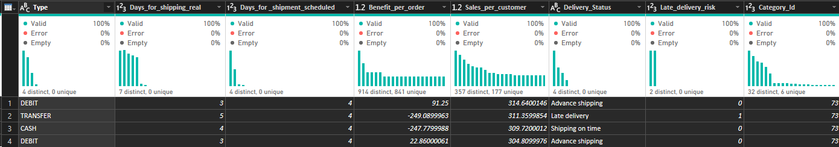
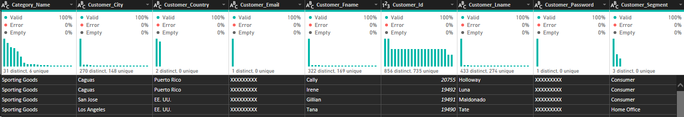
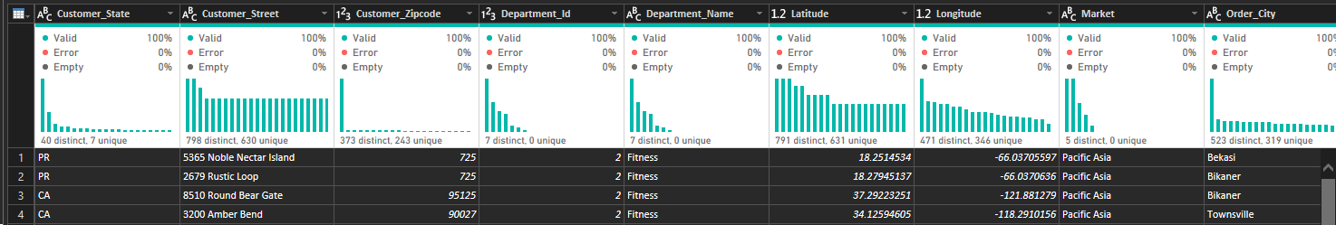
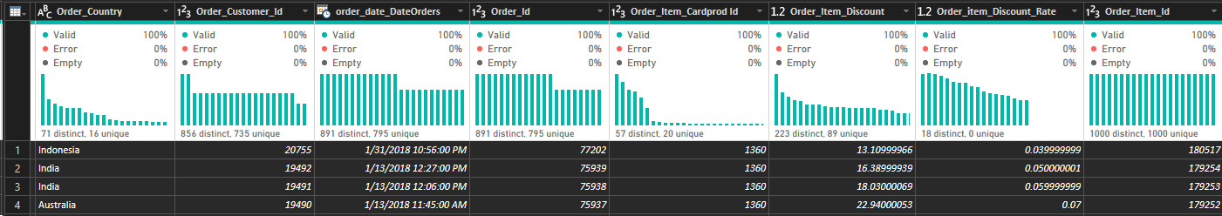
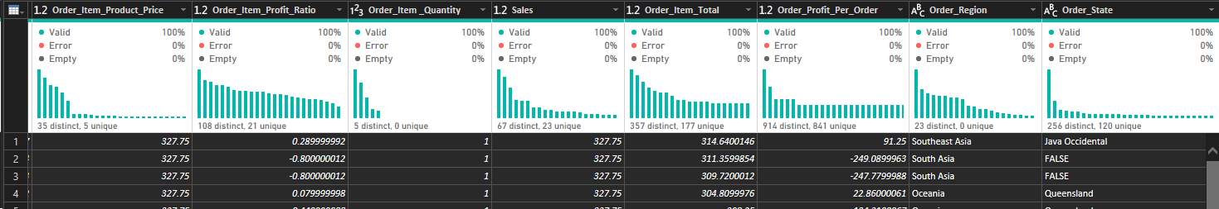
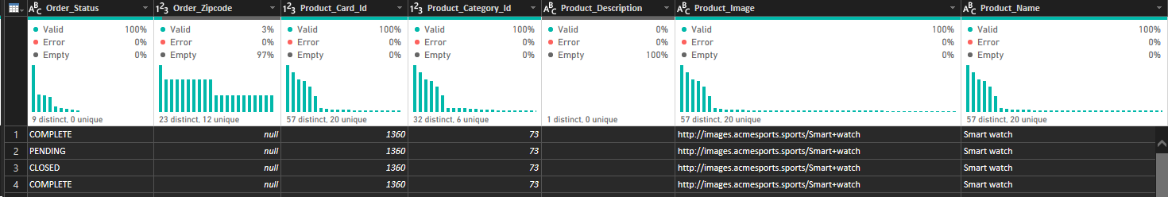
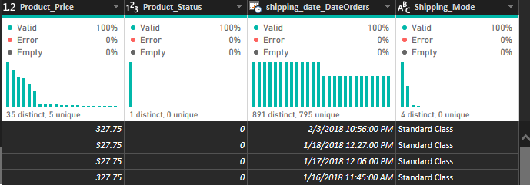

Part B: Data Cleaning and Transformation in Power Query (20 Marks)
The dataset was loaded into Power BI and directly transformed.
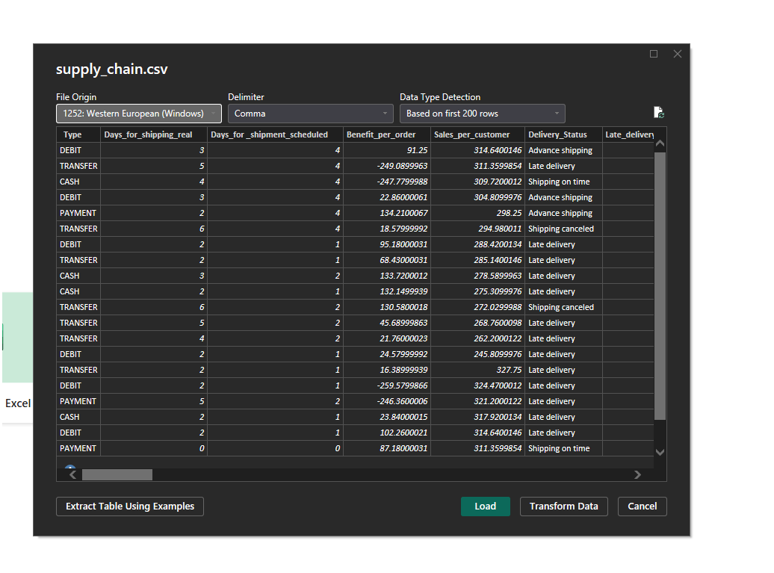

Part C: Data Modeling (15 Marks)

Part D: DAX Measures and Calculated Columns (20 Marks)

Part E: Dashboard Design and Visualization (20 Marks)

Part F: Analytical Insights and Business Recommendations (10 Marks)

Part G: GitHub Repository and Documentation (5 Marks)

